**SPRINT-2**

|  |  |
| --- | --- |
| Date | 16 November 2022 |
| Team ID | PNT2022TMID48655 |
| Project Name | Gas Leakage monitoring and alerting system for industries |

# UPDATED CODE OF THE DEVELOPED SYSTEM:

#include <LiquidCrystal.h>

const int rs = 2, en = 3, d4 = 4, d5 = 5, d6 = 6, d7 = 7;

LiquidCrystal lcd(rs, en, d4, d5, d6, d7);

int buzzer = 8;

int relay = 9;

int g =0;

void setup()

{

lcd.begin(16, 2);

lcd.clear();

lcd.setCursor(0, 0);

lcd.print(" AUTOMATIC GAS");

lcd.setCursor(0, 1);

lcd.print("LEKAGE DETECTION");

delay(1000);

pinMode(buzzer, OUTPUT);

pinMode(relay, OUTPUT);

pinMode(g, INPUT);

Serial.begin(9600);

Serial.println("AT");

delay(500);

Serial.println("AT+CMGF=1");

delay(500);

Serial.print("AT+CMGS=");

Serial.print("\"");

Serial.print("9842108409");

Serial.println("\"");

delay(500);

Serial.print("welcome");

delay(500);

Serial.println((char)26); // End AT command with a ^Z, ASCII code 26

delay(1000);

}

void loop()

{

float g = analogRead(A0); // gas

g=5*(g/1023);

g=g*10;

delay(100);

lcd.clear();

lcd.setCursor(0,0);

lcd.print("GAS LEVEL:");

lcd.setCursor(10,0);

lcd.print(g);

delay(1000);

if(g>20)

{

lcd.clear();

lcd.setCursor(0,0);

lcd.print("gas level high");

delay(1000);

digitalWrite(9, HIGH);

digitalWrite(8, LOW);

Serial.println("AT");

delay(500);

Serial.println("AT+CMGF=1");

delay(500);

Serial.print("AT+CMGS=");

Serial.print("\"");

Serial.print("9842108409");

Serial.println("\"");

delay(500);

Serial.print("gas level high");

delay(500);

Serial.print(g);

delay(500); // End AT command with a ^Z, ASCII code 26

delay(1000);

}

else

{

digitalWrite(9, LOW);

digitalWrite(8, HIGH);

delay(1000);

}

}

**CIRCUIT DIAGRAM:**



**OUTPUT IN LEAKAGE:**

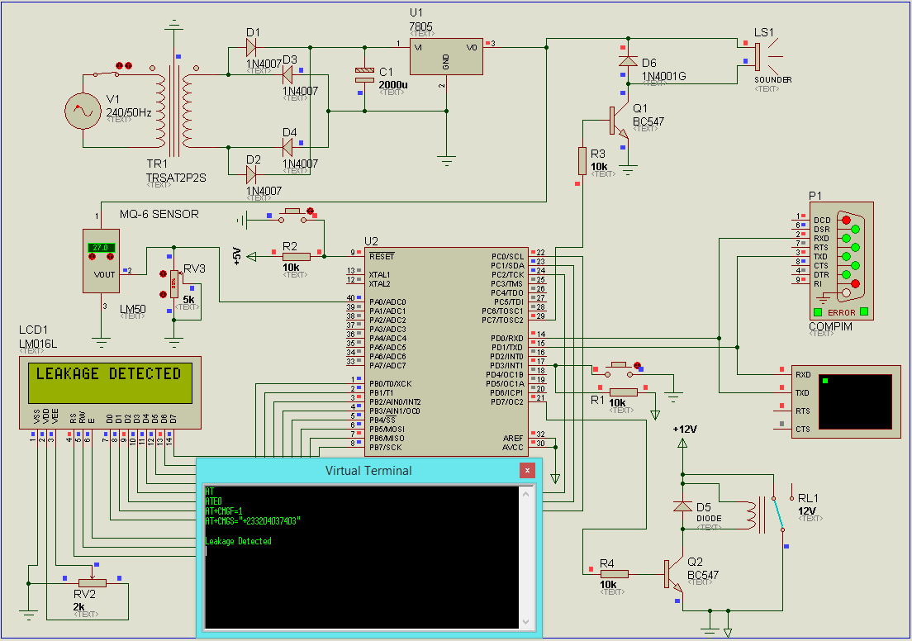

**RESULTS OF OUTPUT POWER SUPPLY:**

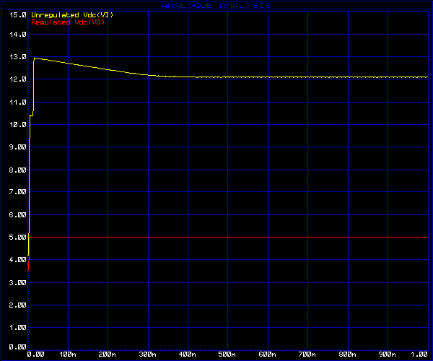

**OUTPUT IN MOBILE DEVICE:**

